

Trustee
information pack
2025



BCOP (Broadening Choices for Older People) Waterside House, Unit 3, Waterside Business Park, 1649 Pershore Road, Stirchley, Birmingham,
B30 3DR Tel: 0121 459 7670 Email: general@bcop.org.uk

Trustees
BCOP, Birmingham
This position is not remunerated but reasonable expenses (e.g.travel) will be paid

BCOP was founded circa 75 years ago to support older people living in Birmingham with their housing needs. Today it continues to provide a range of services, including nursing homes, independent and supported housing, and additional services such as welfare guidance and a handyperson scheme. BCOP nursing homes have dementia care provision with therapeutic activities such as animal assisted therapy and Sensory Street.

The Board wishes to recruit new trustees who can bring passion and commitment to the role and who will relish the opportunity to help shape the future strategy and direction of the charity. We are very interested in welcoming applications from those who have been affected by the services we offer. It is not necessary for applicants to have been involved in Board level roles previously. We particularly welcome applications from individuals with skills in the following areas:

- Social housing property/capital projects
- Senior/strategic expertise in care home sector
- Human Resources
- Business Development/ Commercial acumen
- Marketing & Fundraising
- Finance/Accountancy or Investment Management
- Legal

All new trustees will have the opportunity to take part in an induction programme so they get to know the organisation, the Executive and fellow Board members and acquire the information they need to fulfil their role as a trustee.

Closing date for applications: Recruitment is ongoing. Please submit your application at the earliest opportunity as we will consider applications upon receipt on an on-going basis.

More information about BCOP is available on our website at www.bcop.org.uk

19th March 2024

Dear Applicant
Thank you for your interest in joining the Board of BCOP, where we are committed to providing the highest standard of care and support for older people.
We are a small but innovative organisation that has operated for 75 years and were recently described by a stakeholder as the “…. best care organisation we have ever dealt with.”
BCOP has consolidated its position and reputation over the past few years; despite the challenges of the pandemic, and we are looking forward to a continued bright future. We intend the charity to play an increasing key role in the provision of high quality care, addressing the evolving health and wellbeing needs of our residents and tenants.
The remit of the Board is varied and challenging, especially in the current economic climate and given the growing needs of an increasingly ageing population, but ultimately it is very rewarding work. I would warmly encourage you to apply for a trustee role if you feel suited to our mission, values and objectives and you have experience and skills which will benefit BCOP.
I hope that you will find the information in this pack comprehensive. If you have any questions about the role of trusteeship, please don’t hesitate to contact Helen Gore, CEO, by phone 0121 459 7670 or email: helen.gore@bcop.org.uk to arrange an informal chat.
We look forward to hearing from you.
With best wishes


Debbie Sizer
Chair
About BCOP
BCOP was originally founded in May 1946 as the Birmingham Development Council for Old People’s Welfare. Early in 1947, the name was simplified to Birmingham Council for Old People, until the present day when the organisation is simply known as BCOP, with a registered name of Broadening Choices for Older People.

Since its early days BCOP has been actively involved in the raising of funds to benefit older people, initially in the form of accommodation and care, expanding its latter day operations into:

Nursing Homes
High quality care services in our well designed, comfortable nursing homes. We have well-motivated and trained staff, enabling us to create as homely and non-institutional an environment as possible.

Dementia care
Dementia units based at two of our care homes, with highly trained staff, drawing on the most recent research in how best to deliver services for people living with dementia.

Animal assisted therapy
Research has shown that regular interaction with animals can enhance the lives of older people, particularly those living with dementia. It often improves social, emotional or cognitive functioning.

Supported housing
Mainly one-bedroom flats for older people who do not need residential care, but due to poor health or mobility, they do need extra support and security. Each scheme benefits from the involvement of a scheme manager.

Independent living
Self-contained flats and bungalows for people over sixty who wish – and are able – to lead a completely independent lifestyle, but with the security of an alarm call system.

Welfare guidance
BCOP offers a wide range of information services for older people, such as a list of reputable contractors, telephone numbers of health services, housing and public health departments and where to purchase aids and adaptations.

Grants facilitation
BCOP can help older people in financial difficulties by securing grants for them from various charities to purchase items such as cookers and fridges and to have essential repair work carried out on their property.

Handyperson scheme
Our aim is to increase safety and prevent falls by carrying out small, minor repairs for older people living in their own homes.

Staff training
BCOP provides high quality training for staff, using our own internal expertise, in addition to using external training providers. This allows us to frame our learning opportunities to the specific needs identified by our operational managers.

Research and practice development
BCOP is constantly striving to develop new and innovative approaches to care, working with partners in both service provision and academia.

Throughout its history BCOP has recognised the need to ensure that our resources are directed to those most in need.

What our service users say:
“What surprised me the most is that they’ve got up to fifty residents but they treat each one, in my eyes, as the only person here when they’re with them.
When I come I don’t see uniforms, I see friends. To Mom, she sees them as family…. It’s like a little village, it’s amazing. The environment is just right to make them feel like they’re not in a home.”
Quote from daughter of a resident at Neville Williams House

What our Trustees say:
“In a small organisation, the non-executives on the board offer the executives a pool of people with a variety of expertise and experience which they can use to help the organisation.”
Adrian Jones, Chartered Accountant (retired)

“Being a Board member allows me to maintain a role in influencing the delivery of quality services to older people without making too many demands on my time.
I enjoy the stimulation of the meetings and the company of the other Trustees and the officers of the organisation.”
Dr Nicky Bradbury, Former Clinical Director for older peoples’ mental health services

Our Aims

- To operate homely nursing homes and provide good quality care to residents
- To offer a wide spectrum of care including high dependency nursing, dementia care and end-of life care provision
- To respond to individual need, seeing the person first and not just their condition or chronological age
- To offer transitional or episodic forms of care to assist discharge from hospitals, provide respite for carers, or day care for individuals living in the community
- To balance social needs by combining funding from the public sector with contributions from individuals
- To work in partnership with like-minded organisations to have a wider impact in the community
- To maintain the pioneering spirit with which BCOP was first established in 1946, continually looking for ways to improve the care we offer
- To ensure that our charity is financially sustainable, able to support older people for the long term

Our Values
Whatever their role within our nursing homes, our staff are guided by our four values.
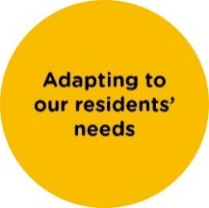




Our care and support is tailored to meet the needs of our residents as individuals. We believe that feeling safe, happy and well cared-for can make a difference not just to the older person but also to their families and friends.
We involve the resident and their family in decisions about their care. We work closely with health and social care professionals and nurture our links with our local communities.
We want residents to feel at home. We recognise and act on the little things, as these often make all the difference – to a resident’s comfort, a family member’s peace of mind, a visitor’s enjoyment or a colleague’s shift.
As a charity, our profits go straight back into our homes so we can adapt, innovate and invest in the best care for our residents, upskilling staff and improving our facilities and equipment.
We know that finding the right care for a loved one is one of the biggest decisions someone can make and we aim to support not just our residents, but their families too.

Our Locations

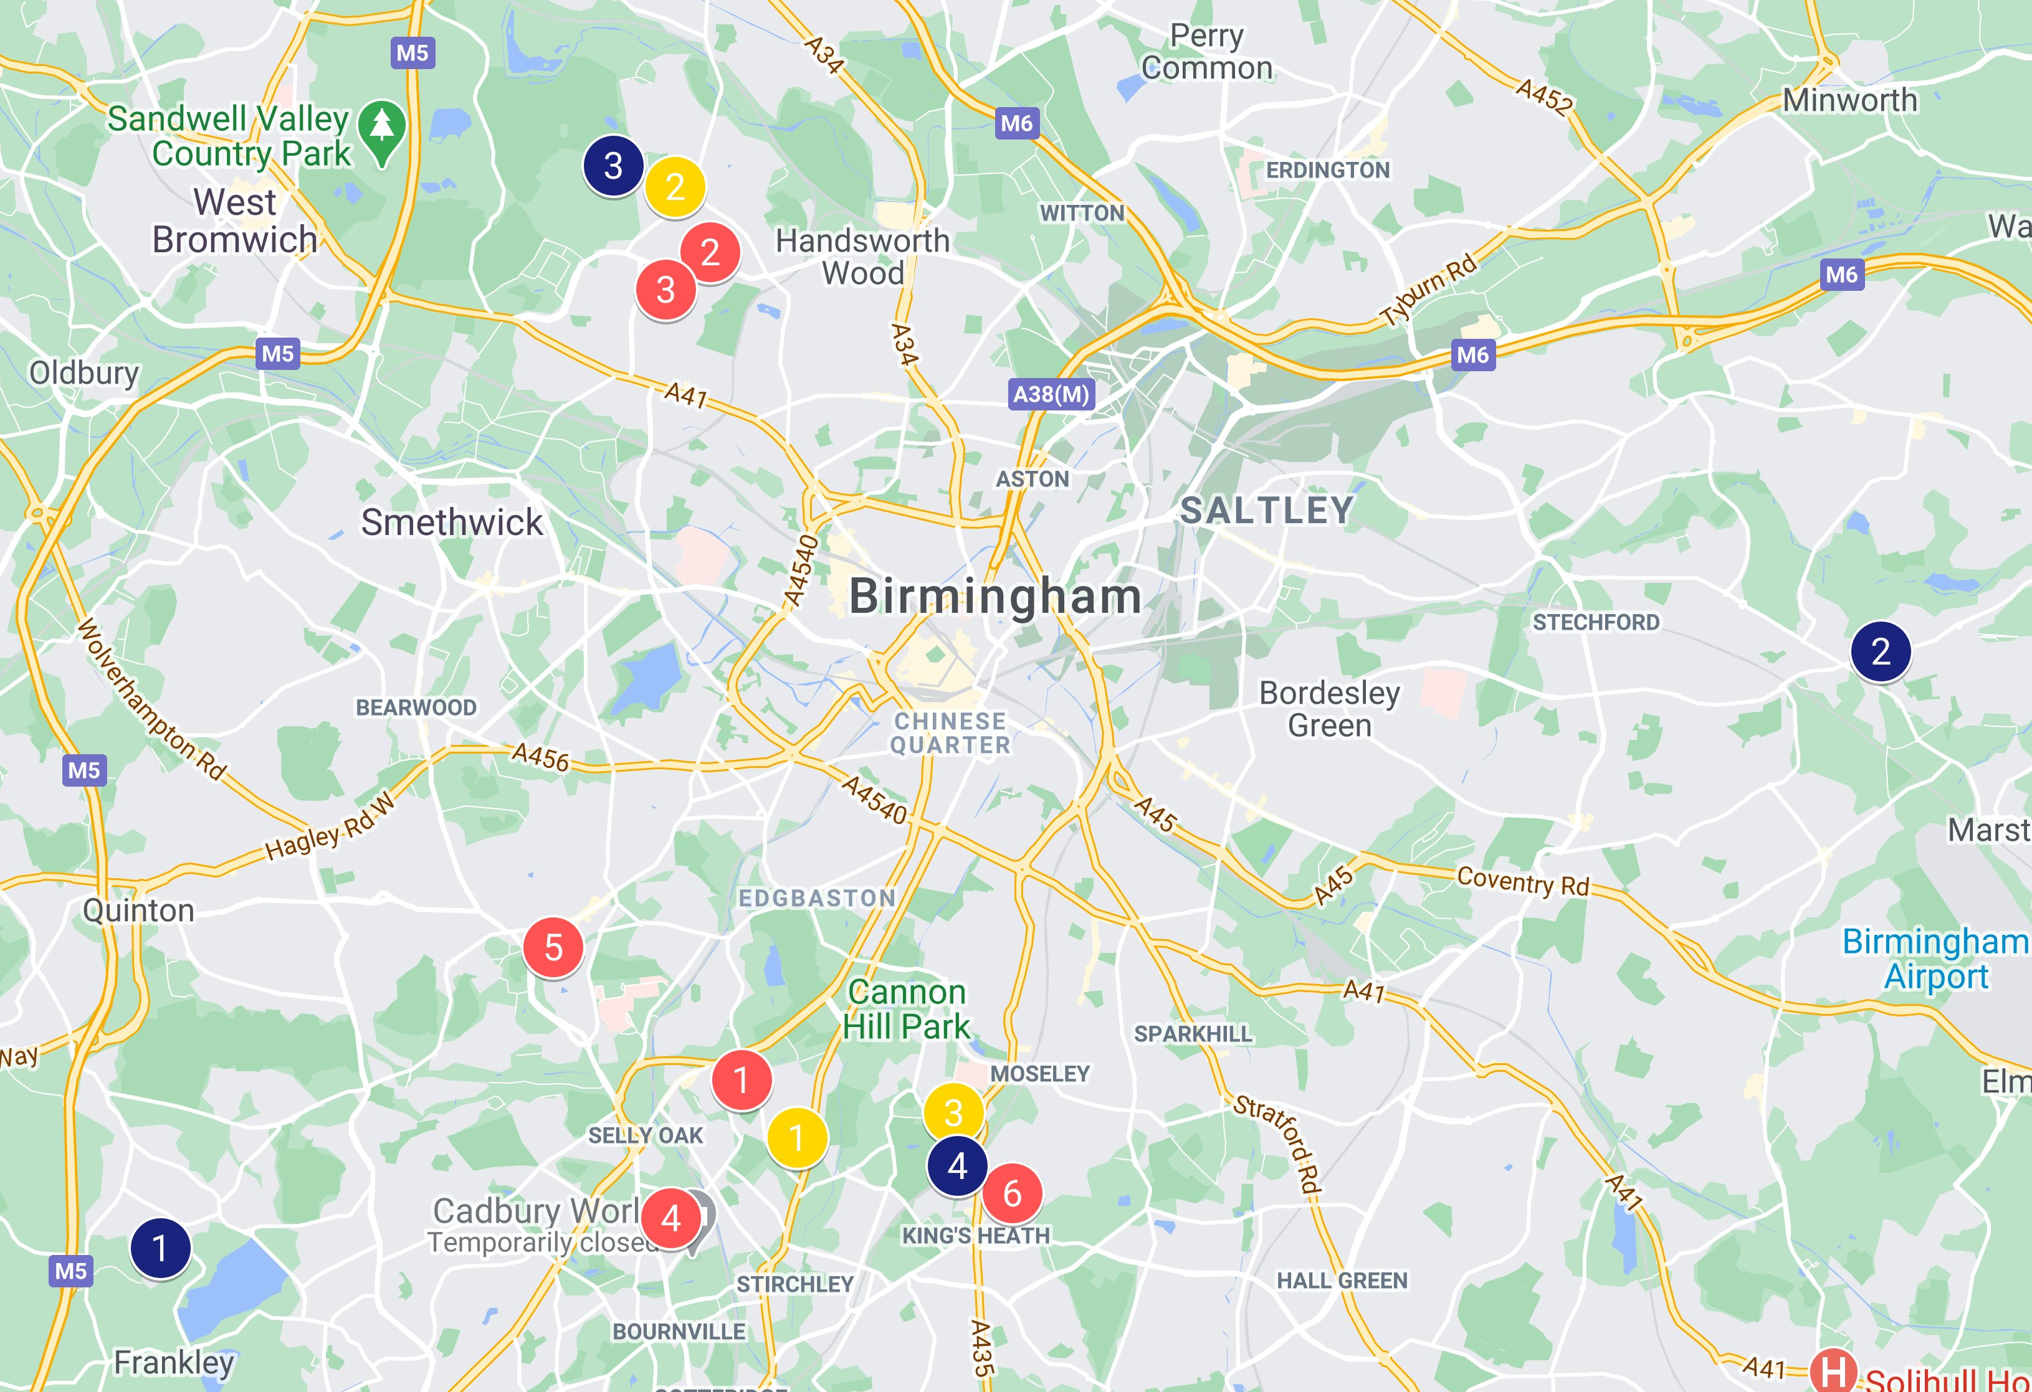

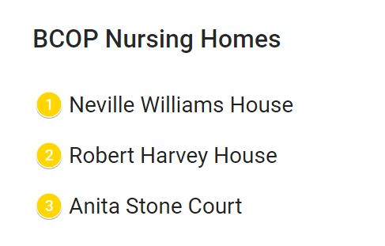
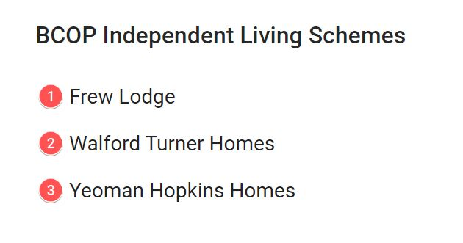
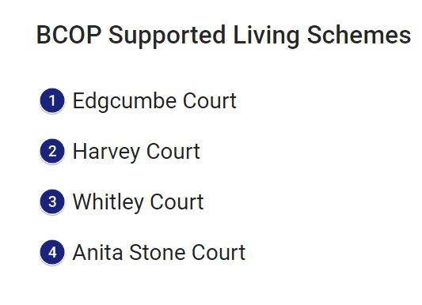

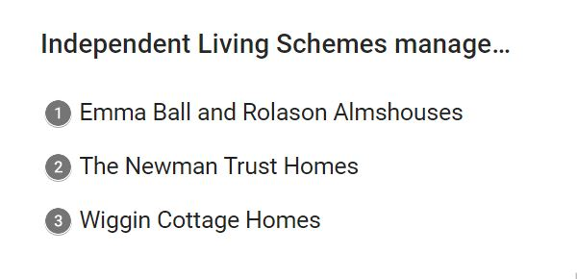
Independent Living Schemes managed by BCOP
The Role of Trustee

The most effective Boards are ones which benefit from the input from individuals from a diverse range of backgrounds, experiences and skill sets. We are particularly interested in applicants with one or more of the following skills and/or experience:

- Social housing property/capital projects
- Senior/strategic care home sector
- Human Resources
- Business Development
- Marketing & Fundraising
- Finance/Accountancy or Investment Management
- Legal

Key responsibilities and accountabilities
Trustees are expected to:

- Ensure that the charity complies with its governing document; the Memorandum and Articles of Association, and adheres to all relevant legislation and regulations
- Contribute actively to the Board of Trustees' role in giving strategic direction to the organisation, setting overall policy, defining goals and evaluating performance against agreed targets
- Ensure that the charity uses its resources wisely and in pursuit of its objectives
- Safeguard the good name and values of the organisation
- Ensure the effective and efficient administration of the organisation
- Protect and manage the assets of the organisation and to ensure the financial stability of the organisation
- Act in the best interest of the charity and not for their private interest or gain.

In essence, the trustees of the Board hold the charity “in trust” for current and future beneficiaries by:

- Ensuring that the charity has a clear vision, mission and strategic direction and is focused on achieving these
- Being responsible for the performance of the charity and for its “corporate” behaviour
- Acting as guardians of the charity’s assets, both tangible and intangible, taking all due care over their security, deployment and proper application
- Ensuring that the charity’s governance is of the highest possible standard.

Person specification

Trustees of BCOP must offer the following:

- Commitment to BCOP’s remit and objectives and to the organisation’s values
- An interest in accommodation, support and care for older people
- Basic IT skills and access to email
- A willingness to devote the necessary time and effort to their duties as a trustee, including attendance at regular Board and Committee meetings
- A willingness and ability to work constructively as part of a multi-disciplinary Board

All Trustees are expected to act with integrity and as Ambassadors for the charity to support and promote its objectives more widely.

Terms of appointment

Time commitment | We hold four Board meetings per year.  Each Board meeting lasts about 3 hours plus preparation time.  Board meetings are typically held on a Wednesday morning, starting at 9.30am.  During Covid-19, we have been holding meetings virtually but hope to move to a hybrid position, alternating between meetings in-person and virtually. Refreshments are provided when we meet.  New trustees will also be invited to join one of the Committees. BCOP runs two Committees (Audit and Operations), which meet quarterly, to support the work of the Board. Each Committee meets in advance of the quarterly Board meetings, on a Wednesday morning for 2-3 hours.  In addition, trustees are expected to participate in an annual planning event to discuss the strategic direction of the charity, and a mid-year event bringing together Board and staff. There are also opportunities to join Working Groups focused on particular projects or proposals.  Commitment would be equivalent to a day per month.  We are open to review timings of the meeting schedule to be more flexible for trustees who are in full-time employment.  Finally, dedicated time would also be required from new Trustees for induction activities upon joining the Board.
Venue | Board and Committee meetings are held in Birmingham; at one of our sites including our Support Office, currently located in Stirchley, Birmingham, or virtually, typically via Zoom.
Remuneration | The role of Trustee is voluntary, however, reasonable expenses, e.g. travel, can be claimed.

How to apply
If you are interested in becoming a Trustee at BCOP, please complete the application form. Instructions in completing the form have been provided. However, if you would like further assistance, please contact Helen Middleton, Executive Assistant at BCOP, on 0121 459 7670 or executive.assistant@bcop.org.uk.

If you would like to submit an up-to-date CV as well as the application form, please keep this to no more than two pages. We cannot progress your application if you do not complete the application form.

Your completed application form (together with your CV if you are submitting one) should be sent by email to executive.assistant@bcop.org.uk. Please title your email “BCOP Trustee Application.”

Closing date: Recruitment is ongoing and applications will be reviewed as they are received.

