**BCOP Staff Bulletin 26th August 2021**

# 

Staff News

By law, all care home employees must be vaccinated against Covid-19 by 11th November 2021

Changes to self-isolation rules

What to do if your PCR test comes back inconclusive

No change to PPE guidance within the nursing homes

Visiting restrictions removed

We are the Champions!

Health & Safety Committee Volunteers

Changes to CQC Inspections

# Staff News

to our new members of staff

* Mohammed Adnan, Catering Assistant at Neville Williams House
* Catelin Powell, Care Assistant at Neville Williams House
* Samantha Bridgewater, Care Assistant at Anita Stone Court
* Natasha Komarychyn, Home Administrator at Anita Stone Court
* Rosel Miguel, Nurse at Anita Stone Court
* Theresa Carter, Nurse at Anita Stone Court
* Wendy Jane Power, Domestic at Neville Williams House
* Janet Vivero, Nurse at Neville Williams House



* Tracy O’Sullivan is now the Registered Manager of Anita Stone Court with CQC.
* Jackie Simpson-Birkett has been promoted to Care Manager at Neville Williams House.
* Dave Steele, Property Services Manager, came 2nd in an inter-county golf competition last week - look at that trophy!



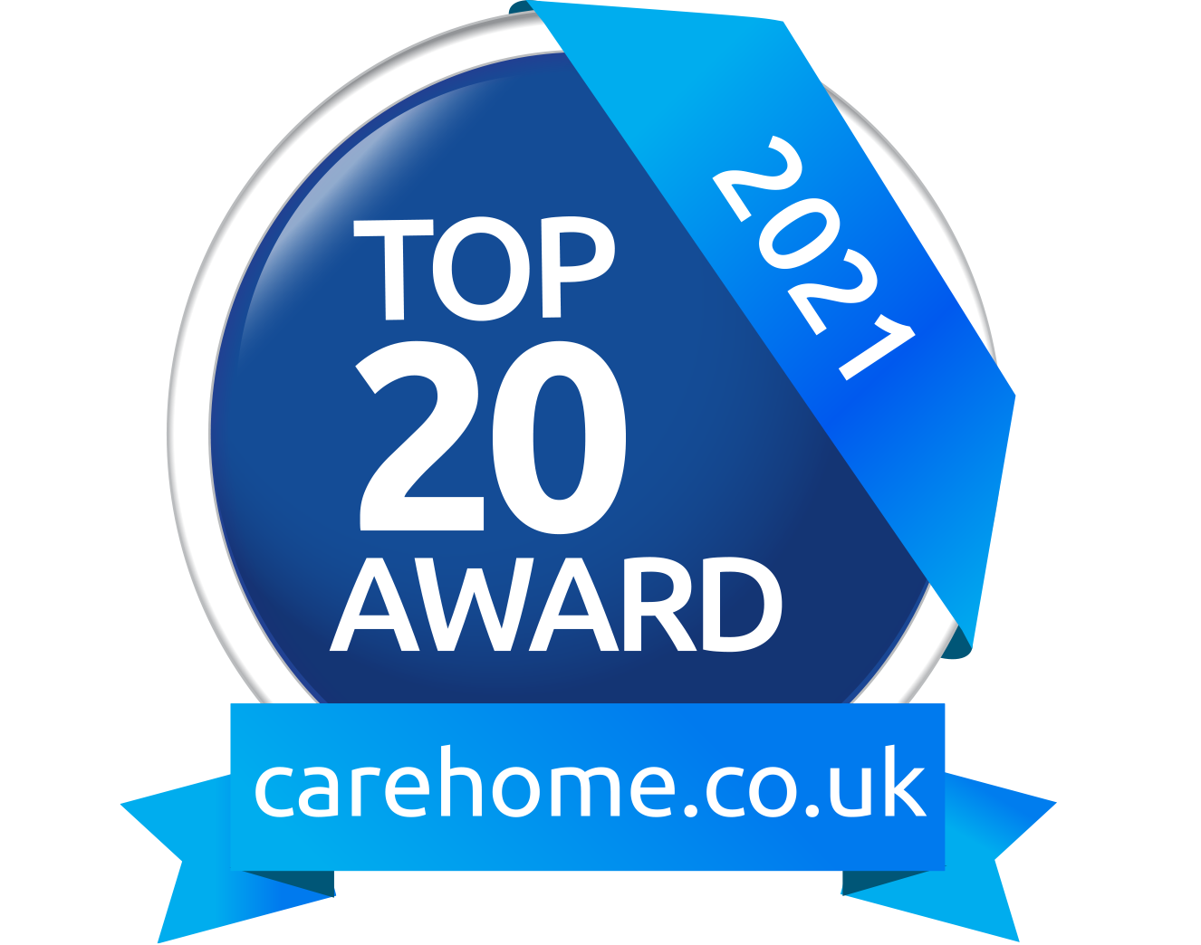

Robert Harvey House has been named as a Top 20 Care Home in West Midlands by carehome.co.uk, based on the number of positive reviews it has received this year.

# 

# By law, all care home employees must be vaccinated against Covid-19 by 11th November 2021

You will have received a letter asking you to provide a Covid-19 Proof of Vaccination letter as soon as possible to your General Manager if you work in the nursing home or to Iarnah Dennis, HR Officer if you work at a different location. From 11th November 2021, we will not legally be allowed to employ anyone to work in our nursing homes who has not been double-vaccinated.

# Changes to self-isolation rules

If you are double-vaccinated, you no longer have to self-isolate if you come into contact with someone who has tested positive for Covid-19 and do not have symptoms yourself. You will need to take a PCR test. If you do have any symptoms, then you must isolate while waiting for your PCR results.

For more information see: <https://www.nhs.uk/conditions/coronavirus-covid-19/self-isolation-and-treatment/when-to-self-isolate-and-what-to-do/>

# What to do if your PCR test comes back inconclusive

If you receive a message saying ‘your coronavirus test did not give a clear result’, you should:

* Still come to work as usual, unless you are experiencing symptoms
* Take another PCR test as soon as possible

# No change to PPE guidance within the nursing homes

You should continue to follow the existing guidance for wearing PPE within the nursing homes.

# Visiting restrictions removed

We’re pleased to be able to confirm that all restrictions on visiting our nursing homes have been removed. Relatives and friends are free to visit without making an appointment.

They will need to show evidence of a negative LFD test before they can enter the home, wear a mask during their visit and follow the infection prevention measures in place in the nursing home.

They cannot visit if they have been notified as a close contact of someone who has tested positive for COVID-19 for 10 days following the notification. They can, however, continue to visit in exceptional circumstances, such as when a resident is nearing the end of their life.

In the event of a Covid-19 outbreak within one of our nursing homes, we may be instructed by the Local Health Protection Team to close the home to visitors or restrict visiting in order to safeguard our residents and staff.

# We are the Champions!

We want to make sure that we continue to offer the highest standards of care possible to our residents. This means keeping on top of new developments, updating our skills and sharing our specialist skills and knowledge with colleagues across the organisation.

We are building a network of Champions whom colleagues can refer to for advice on particular topics. As a Champion you will be responsible for keeping your knowledge and skills up-to-date in your subject area and BCOP will give you access to training and peer networks to enable you to do that.

This list of Champions will be on display on the Staff Noticeboard in each home, so that all staff know who to go to if they need guidance on a particular area.

If you’re a Carer, Senior Carer or nurse with a passion for a particular aspect of your work, please speak to your Care Manager about becoming a Champion for that topic. This could be phlebotomy, catheter care, diabetes care or dementia, for example.

# Health & Safety Committee Volunteers

The General Managers have now completed their IOSH Health & Safety training. We will be creating a BCOP Health & Safety Committee and will shortly be asking for volunteers to be Health & Safety Representatives within each nursing home. If you are interested in this role, please speak to your General Manager for more information.

# Changes to CQC Inspections

We have received formal notification from CQC that they are currently assessing the standard of care provided by care homes via desk reviews of data and documentation, rather than undertaking in person visits.

# 